QA5(c)R SOCIAL and ETHICAL TRADING 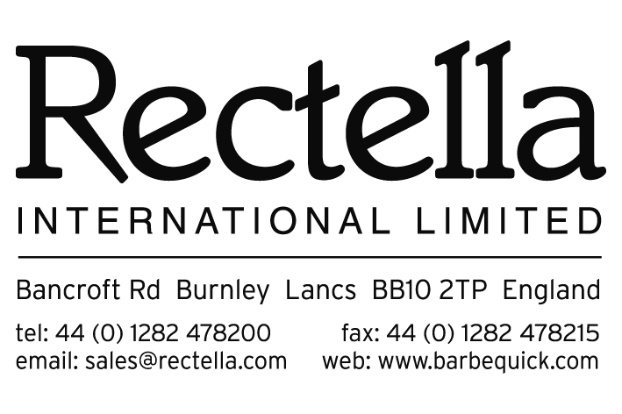
COMPANY / SUPPLIER NAME:

Rectella International Ltd has a strict policy to use only socially and ethically responsible suppliers. We expect our suppliers to monitor the management practices of their supply chain for our goods, using the Ethical Trading Initiative’s base code as the benchmark. Our preferred ethical audit type is SMETA (SEDEX members’ ethical trade audit) – Please see Section 1, Page 3 ‘Social & Ethical Trading & Responsibilities’ within our Supplier Manual for full statement and requirements.
 | YES (Please Tick) | NO (Please Tick)
- Are you a member of SEDEX?

- Do you have a recent Ethical Audit in Place?
(Please provide copy)

Please provide your SEDEX Membership Number :
What is your Self-Assessment form percentage
score on SEDEX? :

- If you answered YES to the questions in the above table, and have provided your Membership Number & Self-Assessment Percentage, please sign & date in the spaces provided at the end of this form and proceed to “Technical Standards & Quality Systems Form 3”.
- If you answered NO to the above, you must join SEDEX. Please refer to the ‘Social & Ethical Trading & Responsibilities’ page 3 in our Supplier Manual & ‘Ethical Audit process Flow Chart’ page 4 in our Supplier Manual for information on this & how to arrange an Ethical Audit. Please advise a Rectella Representative of details once this has been done. Contact details page 12 of our Supplier Manual.

Signature of Supplier Representative :
Printed Name of Supplier Representative :
Date Form Signed :

******************** END of FORM 2 ********************

Documentation Fulfilled – RECTELLA USE ONLY
Documents / Information Required (COMPLETED) | Complete / Documents Received – Yes / No
- Ethical Audit in place & copy of
- SEDEX membership number
- Self-Assessment percentage
- If no, information on joining SEDEX & booking audit details received?

Checked By :
Filled Date :

